GURU GOBIND SINGH POLYTECHNIC, NASIK
COMPUTER ENGINEERING DEPARTMENT PRACTICAL EXAM QUESTIONS
Subject: Mobile Application Development(22619)

- Write a program demonstrate Linear Layout with vertical and horizontal orientation.

XML
<?xml version="1.0" encoding="utf-8"?>
<LinearLayout xmlns:android="http://schemas.android.com/apk/res/android"
android:layout_width="match_parent"
android:layout_height="match_parent"
android:orientation="vertical"
android:padding="16dp">
<!-- Vertical Layout Components -->
<TextView
android:layout_width="wrap_content"
android:layout_height="wrap_content"
android:text="Vertical Layout"
android:textSize="20sp"
android:layout_marginBottom="10dp" />
<Button
android:id="@+id/btn1"
android:layout_width="wrap_content"
android:layout_height="wrap_content"
android:text="Button 1" />
<Button
android:id="@+id/btn2"
android:layout_width="wrap_content"
android:layout_height="wrap_content"
android:text="Button 2"
android:layout_marginTop="10dp" />
<!-- Horizontal Layout -->
<TextView
android:layout_width="wrap_content"
android:layout_height="wrap_content"
android:orientation="horizontal"
android:text="horizontal layout"
android:textSize="20sp"
></TextView>
<LinearLayout
android:layout_width="match_parent"
android:layout_height="wrap_content"
android:orientation="horizontal"
android:layout_marginTop="20dp">
<Button
android:id="@+id/btn3"
android:layout_width="wrap_content"
android:layout_height="wrap_content"
android:text="Left" />
<Button
android:id="@+id/btn4"
android:layout_width="wrap_content"
android:layout_height="wrap_content"
android:text="Right"
android:layout_marginStart="10dp" />
</LinearLayout>
</LinearLayout>

JAVA

package com.example.myapplication;
import android.os.Bundle;
import androidx.appcompat.app.AppCompatActivity;
public class MainActivity extends AppCompatActivity {
@Override
protected void onCreate(Bundle savedInstanceState) {
super.onCreate(savedInstanceState);
setContentView(R.layout.activity_main);
}
}

- Write a program to produce following output using Relative Layout:
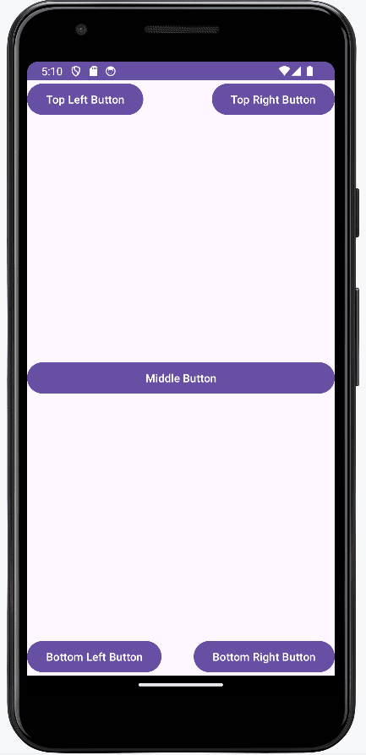

XML
<?xml version="1.0" encoding="utf-8"?>
<RelativeLayout xmlns:android="http://schemas.android.com/apk/res/android"
android:layout_width="match_parent"
android:layout_height="match_parent"
android:padding="16dp">
<!-- Top Left Button -->
<Button
android:id="@+id/btnTopLeft"
android:layout_width="wrap_content"
android:layout_height="wrap_content"
android:text="Top Left Button"
android:layout_alignParentTop="true"
android:layout_alignParentStart="true" />
<!-- Top Right Button -->
<Button
android:id="@+id/btnTopRight"
android:layout_width="wrap_content"
android:layout_height="wrap_content"
android:text="Top Right Button"
android:layout_alignParentTop="true"
android:layout_alignParentEnd="true" />
<!-- Middle Button -->
<Button
android:id="@+id/btnMiddle"
android:layout_width="match_parent"
android:layout_height="wrap_content"
android:text="Middle Button"
android:layout_centerInParent="true" />
<!-- Bottom Left Button -->
<Button
android:id="@+id/btnBottomLeft"
android:layout_width="wrap_content"
android:layout_height="wrap_content"
android:text="Bottom Left Button"
android:layout_alignParentBottom="true"
android:layout_alignParentStart="true" />
<!-- Bottom Right Button -->
<Button
android:id="@+id/btnBottomRight"
android:layout_width="wrap_content"
android:layout_height="wrap_content"
android:text="Bottom Right Button"
android:layout_alignParentBottom="true"
android:layout_alignParentEnd="true" />
</RelativeLayout>

- Write a program to produce following output using Table Layout:

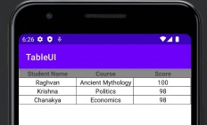

XML

<?xml version="1.0" encoding="utf-8"?>
<TableLayout xmlns:android="http://schemas.android.com/apk/res/android"
android:layout_width="match_parent"
android:layout_height="match_parent"
android:stretchColumns="*"
android:padding="16dp">

<!-- Heading -->
<TableRow>
<TextView
android:layout_span="3"
android:text="TableUI"
android:textSize="24sp"
android:textStyle="bold"
android:gravity="center"
android:padding="10dp" />
</TableRow>

<!-- Header Row -->
<TableRow>
<TextView
android:text="Student Name"
android:textStyle="bold"
android:padding="8dp" />

<TextView
android:text="Course"
android:textStyle="bold"
android:padding="8dp" />

<TextView
android:text="Score"
android:textStyle="bold"
android:padding="8dp" />
</TableRow>

<!-- Row 1 -->
<TableRow>
<TextView
android:text="Rajeevan"
android:padding="8dp" />

<TextView
android:text="Ancient Mythology"
android:padding="8dp" />

<TextView

android:text="100"
android:padding="8dp" />
</TableRow>

<!-- Row 2 -->
<TableRow>
<TextView
android:text="Krishna"
android:padding="8dp" />

<TextView
android:text="Politics"
android:padding="8dp" />

<TextView
android:text="98"
android:padding="8dp" />
</TableRow>

<!-- Row 3 -->
<TableRow>
<TextView
android:text="Chanakya"
android:padding="8dp" />

<TextView
android:text="Economics"
android:padding="8dp" />

<TextView
android:text="98"
android:padding="8dp" />
</TableRow>

</TableLayout>
- Write a program to Frame Layout to display Text over Image.

<?xml version="1.0" encoding="utf-8"?>
<FrameLayout xmlns:android="http://schemas.android.com/apk/res/android"
android:layout_width="match_parent"
android:layout_height="match_parent">
<!-- Background Image -->
<ImageView
android:id="@+id/imageView"
android:layout_width="match_parent"
android:layout_height="match_parent"
android:src="@drawable/sample_image"
android:scaleType="centerCrop" />
<!-- Text Over Image -->
<TextView
android:id="@+id/textView"
android:layout_width="wrap_content"
android:layout_height="wrap_content"
android:text="Welcome to MAD"
android:textSize="24sp"
android:textStyle="bold"
android:textColor="#FFFFFF"
android:layout_gravity="center" />
</FrameLayout>

- Write a program to produce following output using Toggle Button:

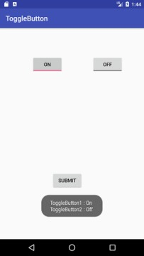

XML
<?xml version="1.0" encoding="utf-8"?>
<LinearLayout xmlns:android="http://schemas.android.com/apk/res/android"
android:layout_width="match_parent"
android:layout_height="match_parent"
android:orientation="vertical"
android:gravity="center"
android:padding="20dp">

<!-- First Toggle Button -->
<ToggleButton
android:id="@+id/toggleButton1"
android:layout_width="wrap_content"
android:layout_height="wrap_content"
android:textOn="ON"
android:textOff="OFF" />

<!-- Second Toggle Button -->
<ToggleButton
android:id="@+id/toggleButton2"
android:layout_width="wrap_content"
android:layout_height="wrap_content"
android:textOn="ON"
android:textOff="OFF"
android:layout_marginTop="20dp" />

<!-- Submit Button -->
<Button
android:id="@+id/button"
android:layout_width="wrap_content"
android:layout_height="wrap_content"
android:text="SUBMIT"
android:layout_marginTop="40dp" />

<!-- Output Text -->
<TextView
android:id="@+id/textView"
android:layout_width="wrap_content"
android:layout_height="wrap_content"
android:textSize="18sp"
android:padding="20dp"
android:layout_marginTop="20dp" />

</LinearLayout>

JAVA

package com.example.togglebuttondemo;

import android.os.Bundle;
import android.widget.Button;
import android.widget.TextView;
import android.widget.ToggleButton;
import androidx.appcompat.app.AppCompatActivity;

public class MainActivity extends AppCompatActivity {

ToggleButton toggleButton1, toggleButton2;
Button button;
TextView textView;

@Override
protected void onCreate(Bundle savedInstanceState) {
super.onCreate(savedInstanceState);
setContentView(R.layout.activity_main);

toggleButton1 = findViewById(R.id.toggleButton1);
toggleButton2 = findViewById(R.id.toggleButton2);
button = findViewById(R.id.button);
textView = findViewById(R.id.textView);

button.setOnClickListener(v -> {
String state1 = toggleButton1.isChecked() ? "On" : "Off";
String state2 = toggleButton2.isChecked() ? "On" : "Off";

textView.setText("ToggleButton1 : " + state1 +
"\nToggleButton2 : " + state2);
});
}
}
- Write a program to design simple login Screen. Check User name and password and if it is correct, display a toast message, “Login Success”, otherwise, “Login Failed”. Assume
suitable GUI.

XML
<?xml version="1.0" encoding="utf-8"?>
<LinearLayout xmlns:android="http://schemas.android.com/apk/res/android"
android:layout_width="match_parent"
android:layout_height="match_parent"
android:orientation="vertical"
android:gravity="center"
android:padding="20dp">

<TextView
android:layout_width="wrap_content"
android:layout_height="wrap_content"
android:text="Login Screen"
android:textSize="24sp"
android:textStyle="bold"
android:layout_marginBottom="20dp"/>

<EditText
android:id="@+id/etUsername"
android:layout_width="match_parent"
android:layout_height="wrap_content"
android:hint="Enter Username" />

<EditText
android:id="@+id/etPassword"
android:layout_width="match_parent"
android:layout_height="wrap_content"
android:hint="Enter Password"
android:inputType="textPassword"
android:layout_marginTop="10dp" />

<Button
android:id="@+id/btnLogin"
android:layout_width="wrap_content"
android:layout_height="wrap_content"
android:text="LOGIN"
android:layout_marginTop="20dp" />

</LinearLayout>

JAVA

package com.example.logindemo;

import android.os.Bundle;
import android.widget.Button;
import android.widget.EditText;
import android.widget.Toast;
import androidx.appcompat.app.AppCompatActivity;

public class MainActivity extends AppCompatActivity {

EditText etUsername, etPassword;
Button btnLogin;

@Override
protected void onCreate(Bundle savedInstanceState) {
super.onCreate(savedInstanceState);
setContentView(R.layout.activity_main);

etUsername = findViewById(R.id.etUsername);
etPassword = findViewById(R.id.etPassword);
btnLogin = findViewById(R.id.btnLogin);

btnLogin.setOnClickListener(v -> {
String username = etUsername.getText().toString();
String password = etPassword.getText().toString();

if (username.equals("admin") && password.equals("1234")) {
Toast.makeText(MainActivity.this,
"Login Success",
Toast.LENGTH_SHORT).show();
} else {
Toast.makeText(MainActivity.this,
"Login Failed",
Toast.LENGTH_SHORT).show();
}
});
}
}

- Write a program to demonstrate Date Picker. Display Selected date using Toast. Assume suitable GUI.
XML
<?xml version="1.0" encoding="utf-8"?>
<LinearLayout xmlns:android="http://schemas.android.com/apk/res/android"
android:layout_width="match_parent"
android:layout_height="match_parent"
android:orientation="vertical"
android:gravity="center"
android:padding="20dp">

<DatePicker
android:id="@+id/datePicker"
android:layout_width="wrap_content"
android:layout_height="wrap_content" />

<Button
android:id="@+id/btnShowDate"
android:layout_width="wrap_content"
android:layout_height="wrap_content"
android:text="SHOW DATE"
android:layout_marginTop="20dp" />

</LinearLayout>
JAVA
package com.example.datepickerdemo;

import android.os.Bundle;
import android.widget.Button;
import android.widget.DatePicker;
import android.widget.Toast;
import androidx.appcompat.app.AppCompatActivity;

public class MainActivity extends AppCompatActivity {

DatePicker datePicker;
Button btnShowDate;

@Override
protected void onCreate(Bundle savedInstanceState) {
super.onCreate(savedInstanceState);
setContentView(R.layout.activity_main);

datePicker = findViewById(R.id.datePicker);
btnShowDate = findViewById(R.id.btnShowDate);

btnShowDate.setOnClickListener(v -> {
int day = datePicker.getDayOfMonth();
int month = datePicker.getMonth() + 1;
int year = datePicker.getYear();

String selectedDate = day + "/" + month + "/" + year;

Toast.makeText(MainActivity.this,
"Selected Date: " + selectedDate,
Toast.LENGTH_SHORT).show();
});
}
}
- Write a program to demonstrate Time Picker. Display Selected Time using Toast. Assume suitable GUI.
XML
<?xml version="1.0" encoding="utf-8"?>
<LinearLayout xmlns:android="http://schemas.android.com/apk/res/android"
android:layout_width="match_parent"
android:layout_height="match_parent"
android:orientation="vertical"
android:gravity="center"
android:padding="20dp">

<TimePicker
android:id="@+id/timePicker"
android:layout_width="wrap_content"
android:layout_height="wrap_content" />

<Button
android:id="@+id/btnShowTime"
android:layout_width="wrap_content"
android:layout_height="wrap_content"
android:text="SHOW TIME"
android:layout_marginTop="20dp" />

</LinearLayout>
JAVA
package com.example.timepickerdemo;

import android.os.Bundle;
import android.widget.Button;
import android.widget.TimePicker;
import android.widget.Toast;
import androidx.appcompat.app.AppCompatActivity;

public class MainActivity extends AppCompatActivity {

TimePicker timePicker;
Button btnShowTime;

@Override
protected void onCreate(Bundle savedInstanceState) {
super.onCreate(savedInstanceState);
setContentView(R.layout.activity_main);

timePicker = findViewById(R.id.timePicker);
btnShowTime = findViewById(R.id.btnShowTime);

btnShowTime.setOnClickListener(v -> {
int hour = timePicker.getHour();
int minute = timePicker.getMinute();

String selectedTime = hour + ":" + minute;

Toast.makeText(MainActivity.this,
"Selected Time: " + selectedTime,
Toast.LENGTH_SHORT).show();
});
}
}

- Write a program to demonstrate Implicit and Explicit Intent. Assume suitable GUI.

JAVA

MAIN ACCTIVITY
package com.example.intentdemo;

import android.content.Intent;
import android.net.Uri;
import android.os.Bundle;
import android.widget.Button;
import androidx.appcompat.app.AppCompatActivity;

public class MainActivity extends AppCompatActivity {

Button btnExplicit, btnImplicit;

@Override
protected void onCreate(Bundle savedInstanceState) {
super.onCreate(savedInstanceState);
setContentView(R.layout.activity_main);

btnExplicit = findViewById(R.id.btnExplicit);
btnImplicit = findViewById(R.id.btnImplicit);

// Explicit Intent
btnExplicit.setOnClickListener(v -> {
Intent intent = new Intent(MainActivity.this, SecondActivity.class);
startActivity(intent);
});

// Implicit Intent
btnImplicit.setOnClickListener(v -> {
Intent intent = new Intent(Intent.ACTION_VIEW);
intent.setData(Uri.parse("https://www.google.com"));
startActivity(intent);
});
}
}

SECOND ACTIVITY

package com.example.intentdemo;

import android.os.Bundle;
import android.widget.TextView;
import androidx.appcompat.app.AppCompatActivity;

public class SecondActivity extends AppCompatActivity {
@Override
protected void onCreate(Bundle savedInstanceState) {
super.onCreate(savedInstanceState);

TextView textView = new TextView(this);
textView.setText("This is Second Activity");
textView.setTextSize(24);

setContentView(textView);
}
}

XML

<?xml version="1.0" encoding="utf-8"?>
<LinearLayout xmlns:android="http://schemas.android.com/apk/res/android"
android:layout_width="match_parent"
android:layout_height="match_parent"
android:orientation="vertical"
android:gravity="center"
android:padding="20dp">

<Button
android:id="@+id/btnExplicit"
android:layout_width="wrap_content"
android:layout_height="wrap_content"
android:text="Explicit Intent" />

<Button
android:id="@+id/btnImplicit"
android:layout_width="wrap_content"
android:layout_height="wrap_content"
android:text="Implicit Intent"
android:layout_marginTop="20dp" />

</LinearLayout>
- Write a program to produce following output:

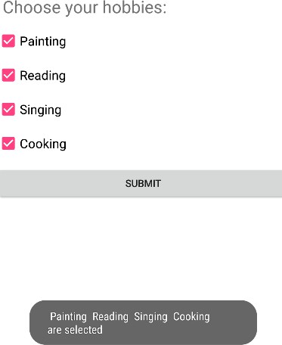

XML
<?xml version="1.0" encoding="utf-8"?>
<LinearLayout xmlns:android="http://schemas.android.com/apk/res/android"
android:layout_width="match_parent"
android:layout_height="match_parent"
android:orientation="vertical"
android:padding="20dp">

<TextView
android:layout_width="wrap_content"
android:layout_height="wrap_content"
android:text="Choose your hobbies:"
android:textSize="22sp"
android:textStyle="bold"
android:layout_marginBottom="20dp"/>

<CheckBox
android:id="@+id/cbPainting"
android:layout_width="wrap_content"
android:layout_height="wrap_content"
android:text="Painting" />

<CheckBox
android:id="@+id/cbReading"
android:layout_width="wrap_content"
android:layout_height="wrap_content"
android:text="Reading" />

<CheckBox
android:id="@+id/cbSinging"
android:layout_width="wrap_content"
android:layout_height="wrap_content"
android:text="Singing" />

<CheckBox
android:id="@+id/cbCooking"
android:layout_width="wrap_content"
android:layout_height="wrap_content"
android:text="Cooking" />

<Button
android:id="@+id/btnSubmit"
android:layout_width="match_parent"
android:layout_height="wrap_content"
android:text="SUBMIT"
android:layout_marginTop="20dp" />

</LinearLayout>
JAVA

package com.example.checkboxdemo;

import android.os.Bundle;
import android.widget.Button;
import android.widget.CheckBox;
import android.widget.Toast;
import androidx.appcompat.app.AppCompatActivity;

public class MainActivity extends AppCompatActivity {

CheckBox cbPainting, cbReading, cbSinging, cbCooking;
Button btnSubmit;

@Override
protected void onCreate(Bundle savedInstanceState) {
super.onCreate(savedInstanceState);
setContentView(R.layout.activity_main);

cbPainting = findViewById(R.id.cbPainting);
cbReading = findViewById(R.id.cbReading);
cbSinging = findViewById(R.id.cbSinging);
cbCooking = findViewById(R.id.cbCooking);
btnSubmit = findViewById(R.id.btnSubmit);

btnSubmit.setOnClickListener(v -> {
String selected = "";

if (cbPainting.isChecked())
selected += "Painting ";
if (cbReading.isChecked())
selected += "Reading ";
if (cbSinging.isChecked())
selected += "Singing ";
if (cbCooking.isChecked())
selected += "Cooking ";

Toast.makeText(MainActivity.this,
selected + "are selected",
Toast.LENGTH_SHORT).show();
});
}
}

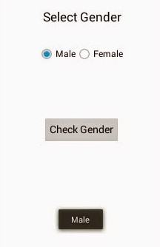
- Write a program to produce following output:

XML
<?xml version="1.0" encoding="utf-8"?>
<LinearLayout xmlns:android="http://schemas.android.com/apk/res/android"
android:layout_width="match_parent"
android:layout_height="match_parent"
android:orientation="vertical"
android:gravity="center"
android:padding="20dp">

<TextView
android:layout_width="wrap_content"
android:layout_height="wrap_content"
android:text="Select Gender"
android:textSize="22sp"
android:textStyle="bold"
android:layout_marginBottom="40dp"/>

<RadioGroup
android:id="@+id/radioGroupGender"
android:layout_width="wrap_content"
android:layout_height="wrap_content"
android:orientation="horizontal"
android:layout_marginBottom="50dp">

<RadioButton
android:id="@+id/radioMale"
android:layout_width="wrap_content"
android:layout_height="wrap_content"
android:text="Male"
android:textSize="18sp"
android:checked="true"
android:layout_marginEnd="30dp"/>

<RadioButton
android:id="@+id/radioFemale"
android:layout_width="wrap_content"
android:layout_height="wrap_content"
android:text="Female"
android:textSize="18sp"/>
</RadioGroup>

<Button
android:id="@+id/btnCheckGender"
android:layout_width="200dp"
android:layout_height="wrap_content"
android:text="Check Gender"
android:layout_marginBottom="60dp"/>

<Button
android:id="@+id/btnResult"
android:layout_width="180dp"
android:layout_height="wrap_content"
android:text="Male"/>

</LinearLayout>

JAVA

package com.example.gendertest;

import android.os.Bundle;
import android.view.View;
import android.widget.Button;
import android.widget.RadioButton;
import android.widget.RadioGroup;
import android.widget.Toast;
import androidx.appcompat.app.AppCompatActivity;

public class MainActivity extends AppCompatActivity {

private RadioGroup radioGroupGender;
private Button btnCheckGender;
private Button btnResult;

@Override
protected void onCreate(Bundle savedInstanceState) {
super.onCreate(savedInstanceState);
setContentView(R.layout.activity_main);

// Find views
radioGroupGender = findViewById(R.id.radioGroupGender);
btnCheckGender = findViewById(R.id.btnCheckGender);
btnResult = findViewById(R.id.btnResult);

// Default value
btnResult.setText("Male");

// Button click listener
btnCheckGender.setOnClickListener(new View.OnClickListener() {
@Override
public void onClick(View v) {
int selectedId = radioGroupGender.getCheckedRadioButtonId();

if (selectedId != -1) {
RadioButton selectedRadio = findViewById(selectedId);
String gender = selectedRadio.getText().toString();

btnResult.setText(gender);

Toast.makeText(MainActivity.this,
"Selected: " + gender,
Toast.LENGTH_SHORT).show();
} else {
Toast.makeText(MainActivity.this,
"Please select a gender",
Toast.LENGTH_SHORT).show();
}
}
});
}
}

- Write a program to produce following output using ListView:
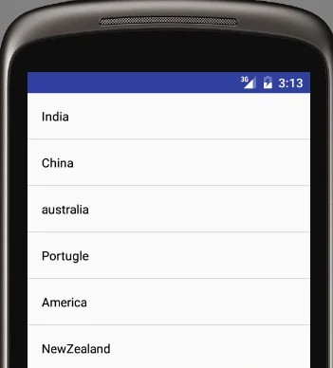

XML
<?xml version="1.0" encoding="utf-8"?>
<LinearLayout xmlns:android="http://schemas.android.com/apk/res/android"
android:layout_width="match_parent"
android:layout_height="match_parent"
android:orientation="vertical">

<!-- ListView -->
<ListView
android:id="@+id/listView"
android:layout_width="match_parent"
android:layout_height="match_parent"
android:divider="#CCCCCC"
android:dividerHeight="1dp"/>

</LinearLayout>
JAVA
package com.example.countryapp;

import android.os.Bundle;
import android.view.View;
import android.widget.AdapterView;
import android.widget.ArrayAdapter;
import android.widget.ListView;
import android.widget.Toast;
import androidx.appcompat.app.AppCompatActivity;

public class MainActivity extends AppCompatActivity {

ListView listView;
String[] countries = {
"India",
"China",
"australia",
"Portugle",
"America",
"NewZealand"
};

@Override
protected void onCreate(Bundle savedInstanceState) {
super.onCreate(savedInstanceState);
setContentView(R.layout.activity_main);

listView = findViewById(R.id.listView);

// Simple ArrayAdapter with default layout
ArrayAdapter<String> adapter = new ArrayAdapter<>(
this,
android.R.layout.simple_list_item_1,
countries
);

listView.setAdapter(adapter);

// Optional: Show toast when item is clicked
listView.setOnItemClickListener(new AdapterView.OnItemClickListener() {
@Override
public void onItemClick(AdapterView<?> parent, View view, int position, long id) {
String selectedCountry = countries[position];
Toast.makeText(MainActivity.this,
"You selected: " + selectedCountry,
Toast.LENGTH_SHORT).show();
}
});
}
}
- Write a program to produce following output using GridView:

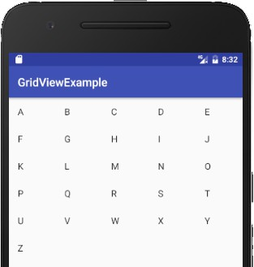
XML
<?xml version="1.0" encoding="utf-8"?>
<LinearLayout xmlns:android="http://schemas.android.com/apk/res/android"
android:layout_width="match_parent"
android:layout_height="match_parent"
android:orientation="vertical">

<!-- Blue Title Bar -->
<TextView
android:layout_width="match_parent"
android:layout_height="50dp"
android:background="#1976D2"
android:text="GridViewExample"
android:textColor="#FFFFFF"
android:textSize="18sp"
android:gravity="center_vertical"
android:paddingLeft="16dp"/>

<!-- GridView -->
<GridView
android:id="@+id/gridView"
android:layout_width="match_parent"
android:layout_height="match_parent"
android:numColumns="5"
android:verticalSpacing="10dp"
android:horizontalSpacing="10dp"
android:padding="10dp"
android:stretchMode="columnWidth"/>

</LinearLayout>
JAVA

package com.example.gridviewexample;

import android.os.Bundle;
import android.widget.ArrayAdapter;
import android.widget.GridView;
import androidx.appcompat.app.AppCompatActivity;

public class MainActivity extends AppCompatActivity {

@Override
protected void onCreate(Bundle savedInstanceState) {
super.onCreate(savedInstanceState);
setContentView(R.layout.activity_main);

GridView gridView = findViewById(R.id.gridView);

// Array of alphabets A to Z
String[] letters = {
"A", "B", "C", "D", "E",
"F", "G", "H", "I", "J",
"K", "L", "M", "N", "O",
"P", "Q", "R", "S", "T",
"U", "V", "W", "X", "Y",
"Z"
};

// Simple ArrayAdapter
ArrayAdapter<String> adapter = new ArrayAdapter<>(
this,
android.R.layout.simple_list_item_1,
letters
);

gridView.setAdapter(adapter);

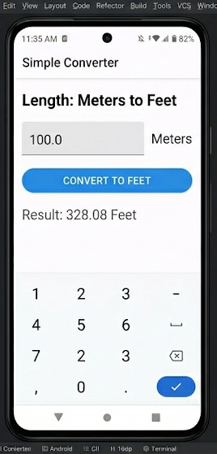
- Write a program to convert length to feet. Assume suitable GUI.

XML

<?xml version="1.0" encoding="utf-8"?>
<LinearLayout xmlns:android="http://schemas.android.com/apk/res/android"
android:layout_width="match_parent"
android:layout_height="match_parent"
android:orientation="vertical"
android:padding="20dp">

<TextView
android:layout_width="wrap_content"
android:layout_height="wrap_content"
android:text="Length: Meters to Feet"
android:textSize="24sp"
android:textStyle="bold"
android:layout_marginBottom="20dp" />

<LinearLayout
android:layout_width="match_parent"
android:layout_height="wrap_content"
android:orientation="horizontal"
android:gravity="center_vertical">

<EditText
android:id="@+id/etMeters"
android:layout_width="0dp"
android:layout_weight="1"
android:layout_height="wrap_content"
android:hint="100.0"
android:inputType="numberDecimal"
android:background="@android:drawable/editbox_background_normal"
android:padding="10dp" />

<TextView
android:layout_width="wrap_content"
android:layout_height="wrap_content"
android:text="Meters"
android:textSize="18sp"
android:layout_marginStart="10dp" />
</LinearLayout>

<Button
android:id="@+id/btnConvert"
android:layout_width="match_parent"
android:layout_height="wrap_content"
android:text="CONVERT TO FEET"
android:backgroundTint="#3498db"
android:textColor="#FFFFFF"
android:layout_marginTop="20dp" />

<TextView
android:id="@+id/tvResult"
android:layout_width="wrap_content"
android:layout_height="wrap_content"
android:text="Result: 0.00 Feet"
android:textSize="20sp"
android:layout_marginTop="20dp" />

</LinearLayout>
JAVA
package com.example.simpleconverter;

import android.os.Bundle;
import android.view.View;
import android.widget.Button;
import android.widget.EditText;
import android.widget.TextView;
import androidx.appcompat.app.AppCompatActivity;

import java.util.Locale;

public class MainActivity extends AppCompatActivity {

// Declare UI components
private EditText etMeters;
private Button btnConvert;
private TextView tvResult;

@Override
protected void onCreate(Bundle savedInstanceState) {
super.onCreate(savedInstanceState);
setContentView(R.layout.activity_main);

// Link components to the XML IDs
etMeters = findViewById(R.id.etMeters);
btnConvert = findViewById(R.id.btnConvert);
tvResult = findViewById(R.id.tvResult);

// Set the click listener for the button
btnConvert.setOnClickListener(new View.OnClickListener() {
@Override
public void onClick(View v) {
convertMetersToFeet();
}
});
}

private void convertMetersToFeet() {
String input = etMeters.getText().toString();

if (!input.isEmpty()) {
try {
double meters = Double.parseDouble(input);

// Formula: 1 Meter = 3.28084 Feet
double feet = meters * 3.28084;

// Format to 2 decimal places to match your image
String resultText = String.format(Locale.getDefault(), "Result: %.2f Feet", feet);
tvResult.setText(resultText);

} catch (NumberFormatException e) {
tvResult.setText("Invalid Input");
}
} else {
tvResult.setText("Please enter a value");
}
}
}

- Write a program to convert INR to USD. Assume suitable GUI.

XML
<?xml version="1.0" encoding="utf-8"?>
<LinearLayout xmlns:android="http://schemas.android.com/apk/res/android"
android:layout_width="match_parent"
android:layout_height="match_parent"
android:orientation="vertical"
android:gravity="center"
android:padding="20dp">

<TextView
android:layout_width="wrap_content"
android:layout_height="wrap_content"
android:text="INR to USD Converter"
android:textSize="24sp"
android:textStyle="bold"
android:layout_marginBottom="20dp"/>

<EditText
android:id="@+id/etInr"
android:layout_width="match_parent"
android:layout_height="wrap_content"
android:hint="Enter Amount in INR"
android:inputType="numberDecimal"/>

<Button
android:id="@+id/btnConvert"
android:layout_width="wrap_content"
android:layout_height="wrap_content"
android:text="CONVERT"
android:layout_marginTop="20dp"/>

<TextView
android:id="@+id/tvResult"
android:layout_width="wrap_content"
android:layout_height="wrap_content"
android:textSize="20sp"
android:layout_marginTop="20dp"/>

</LinearLayout>

JAVA
package com.example.currencyconverter;

import android.os.Bundle;
import android.widget.Button;
import android.widget.EditText;
import android.widget.TextView;
import androidx.appcompat.app.AppCompatActivity;

public class MainActivity extends AppCompatActivity {

EditText etInr;
Button btnConvert;
TextView tvResult;

@Override
protected void onCreate(Bundle savedInstanceState) {
super.onCreate(savedInstanceState);
setContentView(R.layout.activity_main);

etInr = findViewById(R.id.etInr);
btnConvert = findViewById(R.id.btnConvert);
tvResult = findViewById(R.id.tvResult);

btnConvert.setOnClickListener(v -> {
double inr = Double.parseDouble(etInr.getText().toString());
double usd = inr / 83;

tvResult.setText("USD = $" + usd);
});
}
}

- Write a program to implement Splash Screen.

XML
MAIN
<?xml version="1.0" encoding="utf-8"?>
<LinearLayout xmlns:android="http://schemas.android.com/apk/res/android"
android:layout_width="match_parent"
android:layout_height="match_parent"
android:gravity="center"
android:orientation="vertical">

<TextView
android:id="@+id/tvHome"
android:layout_width="wrap_content"
android:layout_height="wrap_content"
android:text="Home Screen"
android:textSize="28sp"
android:textStyle="bold" />

</LinearLayout>
ACTIVITY SPLASH
<?xml version="1.0" encoding="utf-8"?>
<LinearLayout xmlns:android="http://schemas.android.com/apk/res/android"
android:layout_width="match_parent"
android:layout_height="match_parent"
android:orientation="vertical"
android:gravity="center"
android:background="#6200EE">

<TextView
android:layout_width="wrap_content"
android:layout_height="wrap_content"
android:text="Welcome to My App"
android:textColor="#FFFFFF"
android:textSize="30sp"
android:textStyle="bold"/>

</LinearLayout>

JAVA
MAINACTIVITY\
package com.example.splashdemo;

import android.os.Bundle;
import androidx.appcompat.app.AppCompatActivity;

public class MainActivity extends AppCompatActivity {
@Override
protected void onCreate(Bundle savedInstanceState) {
super.onCreate(savedInstanceState);
setContentView(R.layout.activity_main);
}
}

SPLASH ACTIVITY
package com.example.splashdemo;

import android.content.Intent;
import android.os.Bundle;
import android.os.Handler;
import androidx.appcompat.app.AppCompatActivity;

public class SplashActivity extends AppCompatActivity {
@Override
protected void onCreate(Bundle savedInstanceState) {
super.onCreate(savedInstanceState);
setContentView(R.layout.activity_splash);

new Handler().postDelayed(() -> {
Intent intent = new Intent(SplashActivity.this, MainActivity.class);
startActivity(intent);
finish();
}, 3000); // 3 seconds
}
}

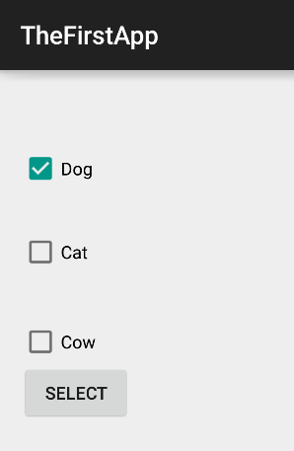
- Write a program to produce the following output. On button click, display selected options:

XML
<?xml version="1.0" encoding="utf-8"?>
<LinearLayout xmlns:android="http://schemas.android.com/apk/res/android"
android:layout_width="match_parent"
android:layout_height="match_parent"
android:orientation="vertical"
android:padding="30dp">

<CheckBox
android:id="@+id/cbDog"
android:layout_width="wrap_content"
android:layout_height="wrap_content"
android:text="Dog"
android:textSize="20sp"
android:layout_marginBottom="20dp"/>

<CheckBox
android:id="@+id/cbCat"
android:layout_width="wrap_content"
android:layout_height="wrap_content"
android:text="Cat"
android:textSize="20sp"
android:layout_marginBottom="20dp"/>

<CheckBox
android:id="@+id/cbCow"
android:layout_width="wrap_content"
android:layout_height="wrap_content"
android:text="Cow"
android:textSize="20sp"
android:layout_marginBottom="20dp"/>

<Button
android:id="@+id/btnSelect"
android:layout_width="wrap_content"
android:layout_height="wrap_content"
android:text="SELECT"
android:padding="15dp"/>

</LinearLayout>
JAVA

package com.example.thefirstapp;

import android.os.Bundle;
import android.view.View;
import android.widget.Button;
import android.widget.CheckBox;
import android.widget.Toast;
import androidx.appcompat.app.AppCompatActivity;

public class MainActivity extends AppCompatActivity {

private CheckBox cbDog, cbCat, cbCow;
private Button btnSelect;

@Override
protected void onCreate(Bundle savedInstanceState) {
super.onCreate(savedInstanceState);
setContentView(R.layout.activity_main);

// Initialize UI components
cbDog = findViewById(R.id.cbDog);
cbCat = findViewById(R.id.cbCat);
cbCow = findViewById(R.id.cbCow);
btnSelect = findViewById(R.id.btnSelect);

btnSelect.setOnClickListener(new View.OnClickListener() {
@Override
public void onClick(View v) {
StringBuilder result = new StringBuilder("Selected: ");

if (cbDog.isChecked()) {
result.append("\nDog");
}
if (cbCat.isChecked()) {
result.append("\nCat");
}
if (cbCow.isChecked()) {
result.append("\nCow");
}

if (result.toString().equals("Selected: ")) {
Toast.makeText(MainActivity.this, "Nothing selected", Toast.LENGTH_SHORT).show();
} else {
Toast.makeText(MainActivity.this, result.toString(), Toast.LENGTH_LONG).show();
}
}
});
}
}
- Write a program to produce following:

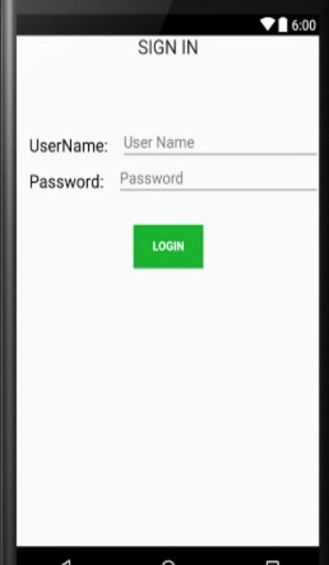
XML

<?xml version="1.0" encoding="utf-8"?>
<LinearLayout xmlns:android="http://schemas.android.com/apk/res/android"
android:layout_width="match_parent"
android:layout_height="match_parent"
android:orientation="vertical"
android:padding="20dp"
android:gravity="center_horizontal">

<TextView
android:layout_width="wrap_content"
android:layout_height="wrap_content"
android:text="SIGN IN"
android:textSize="22sp"
android:textColor="#333333"
android:layout_marginBottom="40dp" />

<LinearLayout
android:layout_width="match_parent"
android:layout_height="wrap_content"
android:orientation="horizontal"
android:layout_marginBottom="15dp">

<TextView
android:layout_width="100dp"
android:layout_height="wrap_content"
android:text="UserName:"
android:textSize="18sp"
android:textColor="#000000" />

<EditText
android:id="@+id/etUser"
android:layout_width="match_parent"
android:layout_height="wrap_content"
android:hint="User Name"
android:inputType="textPersonName" />
</LinearLayout>

<LinearLayout
android:layout_width="match_parent"
android:layout_height="wrap_content"
android:orientation="horizontal"
android:layout_marginBottom="30dp">

<TextView
android:layout_width="100dp"
android:layout_height="wrap_content"
android:text="Password:"
android:textSize="18sp"
android:textColor="#000000" />

<EditText
android:id="@+id/etPass"
android:layout_width="match_parent"
android:layout_height="wrap_content"
android:hint="Password"
android:inputType="textPassword" />
</LinearLayout>

<Button
android:id="@+id/btnLogin"
android:layout_width="wrap_content"
android:layout_height="wrap_content"
android:text="LOGIN"
android:backgroundTint="#27ae60"
android:textColor="#FFFFFF"
android:paddingLeft="30dp"
android:paddingRight="30dp" />

</LinearLayout>

JAVA

package com.example.signinapp;

import android.os.Bundle;
import android.view.View;
import android.widget.Button;
import android.widget.EditText;
import android.widget.Toast;
import androidx.appcompat.app.AppCompatActivity;

public class MainActivity extends AppCompatActivity {

private EditText etUser, etPass;
private Button btnLogin;

@Override
protected void onCreate(Bundle savedInstanceState) {
super.onCreate(savedInstanceState);
setContentView(R.layout.activity_main);

// Initialize components
etUser = findViewById(R.id.etUser);
etPass = findViewById(R.id.etPass);
btnLogin = findViewById(R.id.btnLogin);

btnLogin.setOnClickListener(new View.OnClickListener() {
@Override
public void onClick(View v) {
String username = etUser.getText().toString();
String password = etPass.getText().toString();

if (username.isEmpty() || password.isEmpty()) {
Toast.makeText(MainActivity.this, "Please enter all details", Toast.LENGTH_SHORT).show();
} else {
// Typical validation logic would go here
String message = "Logging in: " + username;
Toast.makeText(MainActivity.this, message, Toast.LENGTH_SHORT).show();
}
}
});
}
}

- Write a program to produce the following using ImageButton. Onclick of Button, show Toast Message, which button was clicked.

XML

<?xml version="1.0" encoding="utf-8"?>
<LinearLayout xmlns:android="http://schemas.android.com/apk/res/android"
android:layout_width="match_parent"
android:layout_height="match_parent"
android:orientation="vertical"
android:gravity="center"
android:padding="20dp">

<ImageButton
android:id="@+id/btnHome"
android:layout_width="150dp"
android:layout_height="150dp"
android:src="@drawable/home_icon"
android:scaleType="fitCenter"
android:background="?android:attr/selectableItemBackground"
android:layout_marginBottom="30dp" />

<ImageButton
android:id="@+id/btnYoutube"
android:layout_width="150dp"
android:layout_height="150dp"
android:src="@drawable/youtube_icon"
android:scaleType="fitCenter"
android:background="?android:attr/selectableItemBackground"
android:layout_marginBottom="20dp" />

<TextView
android:layout_width="wrap_content"
android:layout_height="wrap_content"
android:text="YouTube Button"
android:background="@android:color/darker_gray"
android:textColor="@android:color/white"
android:padding="10dp" />

</LinearLayout>

JAVA

package com.example.imagebuttonapp;

import android.os.Bundle;
import android.view.View;
import android.widget.ImageButton;
import android.widget.Toast;
import androidx.appcompat.app.AppCompatActivity;

public class MainActivity extends AppCompatActivity {

private ImageButton btnHome, btnYoutube;

@Override
protected void onCreate(Bundle savedInstanceState) {
super.onCreate(savedInstanceState);
setContentView(R.layout.activity_main);

// Initialize ImageButtons
btnHome = findViewById(R.id.btnHome);
btnYoutube = findViewById(R.id.btnYoutube);

// Set listener for Home Button
btnHome.setOnClickListener(new View.OnClickListener() {
@Override
public void onClick(View v) {
Toast.makeText(MainActivity.this, "Home Button Clicked", Toast.LENGTH_SHORT).show();
}
});

// Set listener for YouTube Button
btnYoutube.setOnClickListener(new View.OnClickListener() {
@Override
public void onClick(View v) {
Toast.makeText(MainActivity.this, "YouTube Button Clicked", Toast.LENGTH_SHORT).show();
}
});
}
}
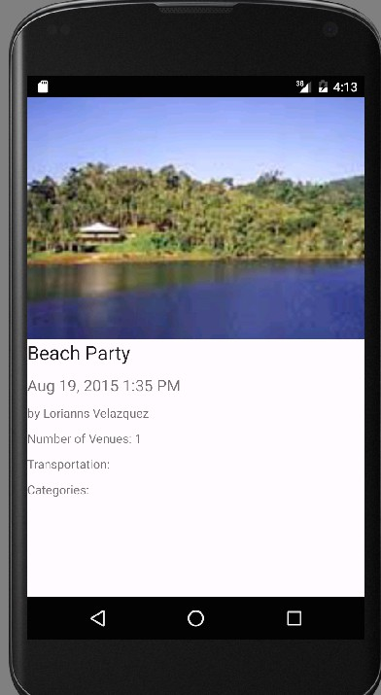
- Write a program to design following output using ImageView and TextView:
XML

<?xml version="1.0" encoding="utf-8"?>
<ScrollView xmlns:android="http://schemas.android.com/apk/res/android"
android:layout_width="match_parent"
android:layout_height="match_parent"
android:background="#FFFFFF">

<LinearLayout
android:layout_width="match_parent"
android:layout_height="wrap_content"
android:orientation="vertical">

<ImageView
android:id="@+id/ivHeader"
android:layout_width="match_parent"
android:layout_height="250dp"
android:scaleType="centerCrop"
android:src="@drawable/beach_image" />

<LinearLayout
android:layout_width="match_parent"
android:layout_height="wrap_content"
android:orientation="vertical"
android:padding="16dp">

<TextView
android:layout_width="wrap_content"
android:layout_height="wrap_content"
android:text="Beach Party"
android:textSize="24sp"
android:textColor="#000000"
android:layout_marginBottom="8dp" />

<TextView
android:layout_width="wrap_content"
android:layout_height="wrap_content"
android:text="Aug 19, 2015 1:35 PM"
android:textSize="16sp"
android:textColor="#757575"
android:layout_marginBottom="12dp" />

<TextView
android:layout_width="wrap_content"
android:layout_height="wrap_content"
android:text="by Lorianns Velazquez"
android:textSize="14sp"
android:textColor="#9E9E9E"
android:layout_marginBottom="8dp" />

<TextView
android:layout_width="wrap_content"
android:layout_height="wrap_content"
android:text="Number of Venues: 1"
android:textSize="14sp"
android:textColor="#9E9E9E"
android:layout_marginBottom="8dp" />

<TextView
android:layout_width="wrap_content"
android:layout_height="wrap_content"
android:text="Transportation:"
android:textSize="14sp"
android:textColor="#9E9E9E"
android:layout_marginBottom="8dp" />

<TextView
android:layout_width="wrap_content"
android:layout_height="wrap_content"
android:text="Categories:"
android:textSize="14sp"
android:textColor="#9E9E9E" />

</LinearLayout>
</LinearLayout>
</ScrollView>
JAVA

package com.example.eventapp;

import android.os.Bundle;
import androidx.appcompat.app.AppCompatActivity;

public class MainActivity extends AppCompatActivity {

@Override
protected void onCreate(Bundle savedInstanceState) {
super.onCreate(savedInstanceState);
// Hiding the action bar to match the full-screen look of the image
if (getSupportActionBar() != null) {
getSupportActionBar().hide();
}
setContentView(R.layout.activity_main);
}
}

Mr. R.A.Kautkar Mrs. G.R.Jagtap

Subject Teacher HOD-CO

